Lesson: 1.1 Structure and Function of a Computer and Importance of Computer Organization and Architecture

* LO 1.1.1 Present and distinguish the differences of computer organization and architectures.

*Computer Architecture* refers to those attributes of a system **visible to a programmer** or, put it another way, those attributes that have **direct impact on the logical execution of a program**. Architectural attributes include:

1. instruction set.
2. number of bits used to represent various data types (e.g. number, characters).
3. I/O mechanisms
4. Techniques for addressing memory.

*Computer Organization* refers to the **operational units** and their **interconnections that realize the architectural specifications**. Organizational attributes include those hardware details transparent to the programmer, such as control signals, interfaces between computer and peripherals, and the memory technology used.

A particular architecture may span many years, but its organization is changing with changing technology, such as the IBM System/370 architecture. Introduces in year 1970 with slower model and model was upgraded to faster version as demand increases without having to abandon software that have already been developed.

* LO 1.1.2 Explain the concepts of Computer structure and function.

A computer is described top down, starting with major components of a computer, describing their structure and function, and proceed to the lower levels of the hierarchy. At each level, the designer is concerned with the structure and function.

* + Structure: The way in which the components are interrelated
  + Function: The operation of each individual component as part of the structure

**Function:**

There are four basic function that a computer can perform:

* 1. *Data Processing* – refers to the processing capability of computer.
  2. *Data Storage* – refers to the capability to store data.
  3. *Data Movement* – capability of the computer to move data between itself and the outside world. Transfer data can be I/O or data communication.
  4. *Control* – manages the computer resources and orchestrates the performance of its functional parts in response to those instructions.

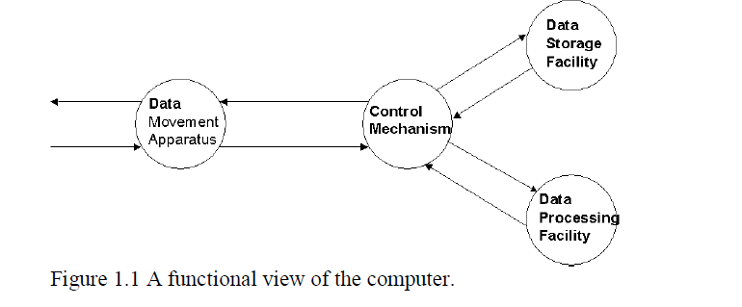

The computer can function as a data movement device, simply transferring data from one peripheral or communications line to another.

It can also function as a data storage device (Figure 1.2b), with data transferred from the external environment to computer storage (read) and vice versa (write).

The final two diagrams show operations involving data processing, on either in storage (Figure 1.2c) or en route between storage and the external environment (Figure 1.2d)

**Structure**

Peripheral devices or communication lines – all linkages of computer to the external environment. Four main structural components of computer:

1. CPU - controls the operation of the computer and performs its data processing functions; often simply referred to as processor.
2. Main memory – store data
3. I/O – Moves data between the computer and its external environment.
4. System Interconnection – Mechanism that provides for communication among CPU, main memory, and I/O.

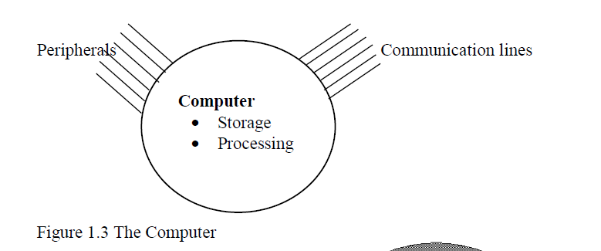

Figure 1.3 is the simplest possible depiction of a computer.

Computer Top Level Structure

* + Peripheral
  + Computer
    - Central Processing Unit, Main Memory, I/O, System Interconnection
  + Communication Lines

Structures of CPU:

1. Control Unit – controls the operation of the CPU. One implementation of this is microprogrammed. This operates by executing microinstructions that define the functionality of the control unit.
   1. Sequencing Logic
   2. Control Unit Registers and Decoders
   3. Control Memory
2. Arithmetic Logic Unit – performs the data processing functions.
3. Registers – provides storage internal to the CPU.
4. CPU interconnection – mechanism that provides for communications the control unit, ALU, and Registers

**Overall Computer Structure**

* + Peripheral
  + Computer
    - Central Processing Unit
      * Control unit
        + Sequencing Logic
        + Control Unit Registers and Decoders
        + Control Memory
      * Arithmetic Logic Unit ALU
      * Registers
      * CPU Interconnection
    - Main Memory
    - I/O
    - System Interconnection
  + Communication Lines
* LO 1.1.3 Inculcate the importance of Computer Organization and Architecture based on IEEE (Institute of Electrical and Electronics Engineers) and ACM (Association of Computing machines) rationale.

The computer lies at the heart of computing. Without it most of the computing disciplines today would be a branch of theoretical mathematics. To be a professional in any field of computing today, one should not regard the computer as just a black box that executes programs by magic. All students of computing should acquire some understanding and appreciation of a computer system’s functional components and characteristics, their performance, and their interactions. There are practical implications as well. Students need to understand computer architecture in order to structure a program so that it runs more efficiently on real machine. In selecting a system to use, they should be able to understand the tradeoff among various components, such as CPU clock speeds vs. memory size. [Reported by the Joint Task Force of Computing Curricula of the IEEE (Institute of Electrical and Electronics Engineers) Computer Society and ACM (Association of Computing Machinery)]